ART 100: INTRODUCTION

MODULE 9: ARCHITECTURE

Quiz

The quiz is worth a total of 50 points. Each question is worth 8.3 points.

1. What are the basic functions of architecture?

2. What adaptations did early architecture make as humans began to consolidate in towns and cities?

3. Match the structural system with the image letter that BEST represents it.

- Post and Lintel
- Colonnade
- Cantilever
- Suspension
- Steel Frame
- Reinforced Concrete
- Geodesic/Truss

a.
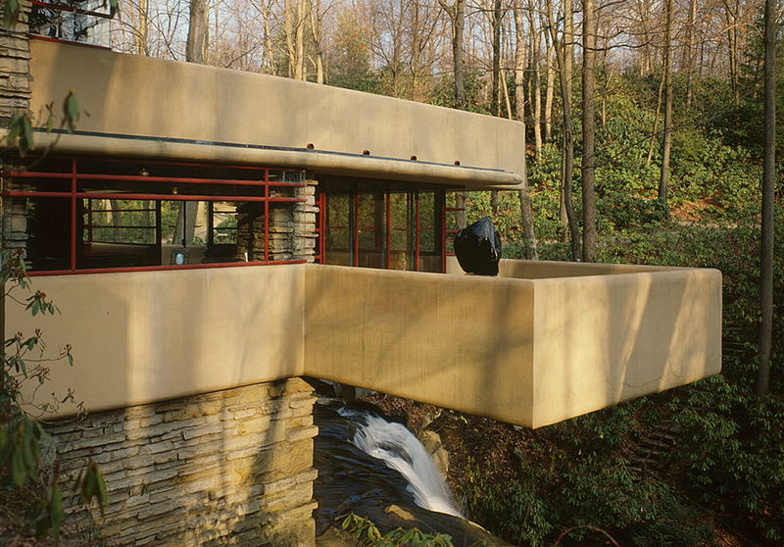
b.
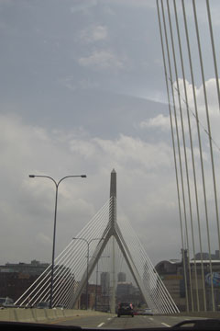

c.
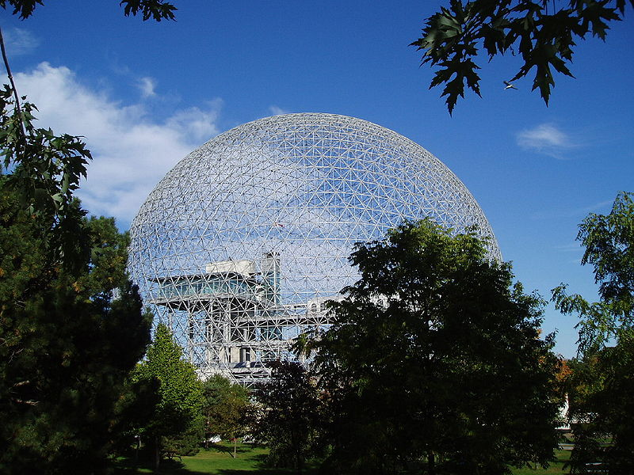
Photo by Eberhard von Nellenburg

